1. List the user commands and redirect the output to /tmp/commands.list :
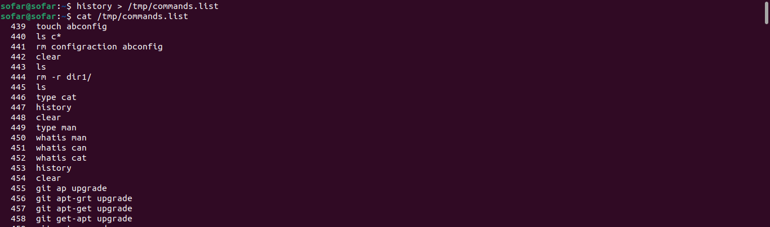
2. Edit in your profile to display date at login and change your prompt permanently.
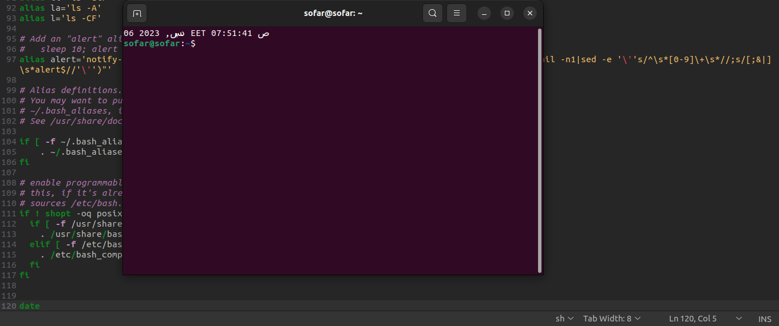
3. What is the command to count the word in a file or number of file in directory.

wc command

a. Count the number of user commands : history | wc

4. What happens if you execute:
a. cat filename1 | cat filename2

it will show the content of filename2 , piping not useful , it will take the input from first cat and send it to second can .

ls | rm :
it’s an error because the rm take names as arguments not as list of files.

Ls /etc | wc -l

Ls /etc/passwd will send the path to wc -l so the output will be one .

5. Write a command to search for all files on the system that, its name is “.profile”.

Find / -iname .profile

6. List the inode numbers of /, /etc, /etc/hosts.

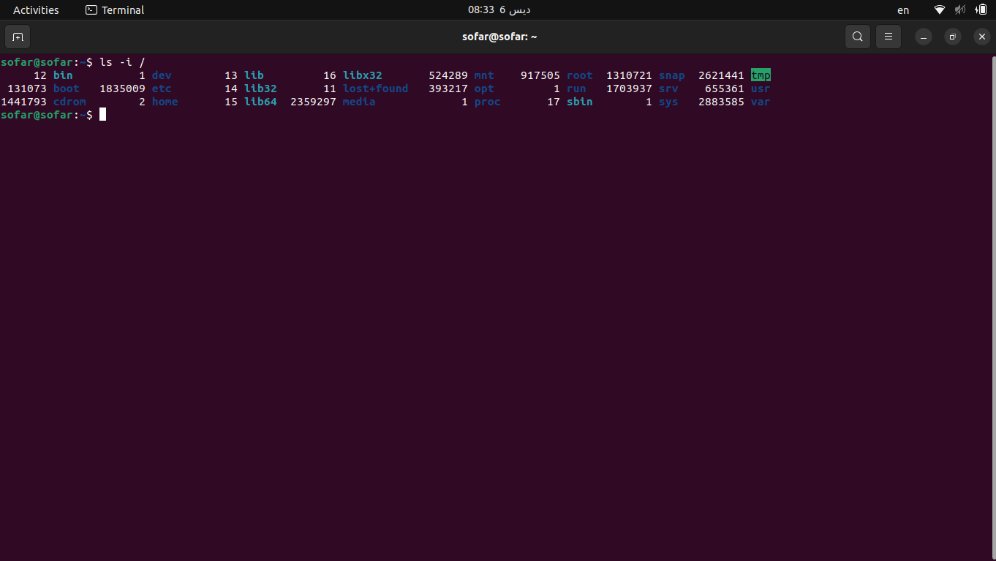

Ls -i /

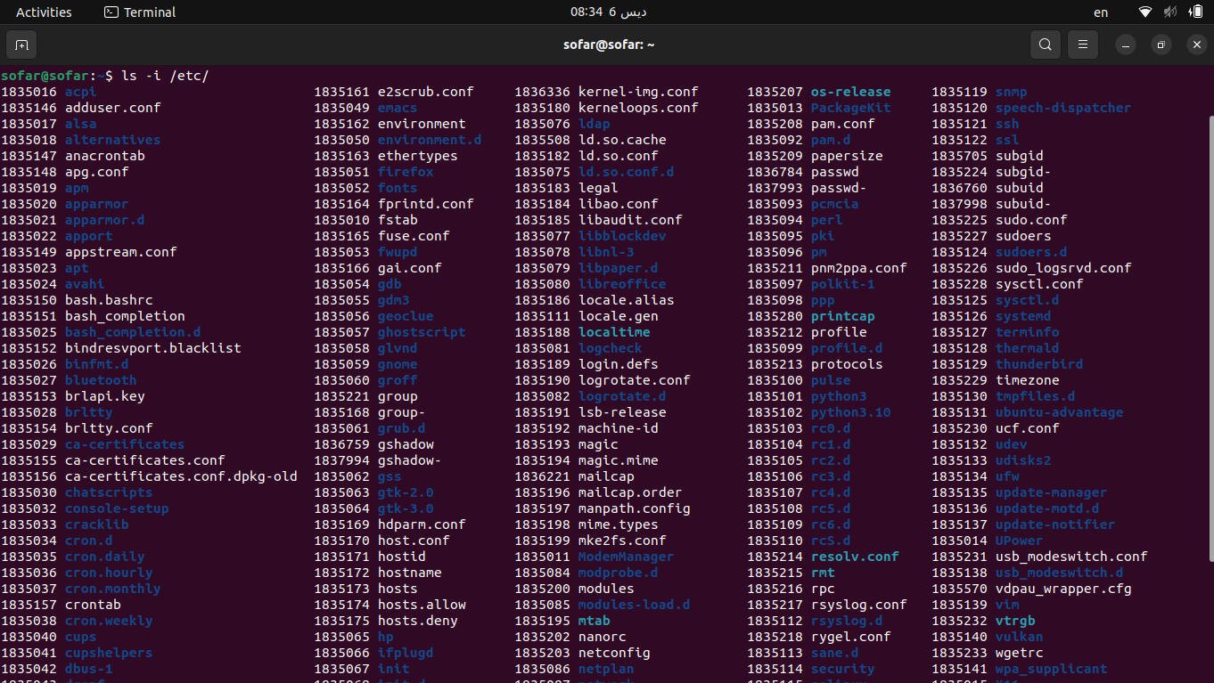
-Ls -i /etc

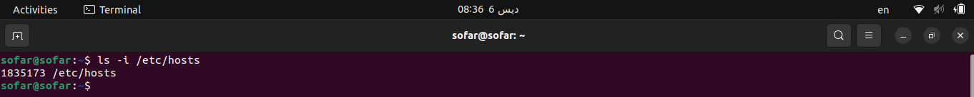
ls -i etc/hosts

7. Create a symbolic link of /etc/passwd in /boot.

ln -s /etc/passwd /boot

8. Create a hard link of /etc/passwd in /boot. Could you? Why?
Yes we can
ln /etc/passwd /boot

9. Echo \ it will jump to the next line, and will print >
Notice the prompt ”>” what is that? and how can you change it from “>” to “:”.
NOTE: search the usage of PS1

iw will go to PS2 to change it :
PS2=": "

